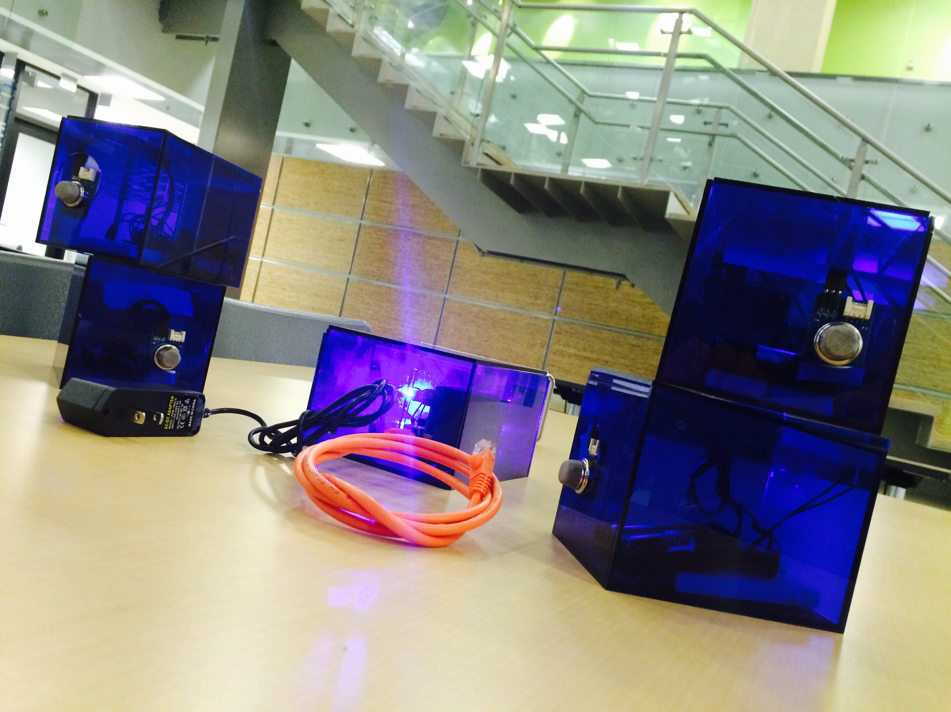

Joris EKPANGBO Louis-Adrien PHILIAS Nirantar SINGH Syed UMAIR Temilolu OLANIYAN;Nirantar Singh

IIT Gas Leak Detector

Business Proposal

# OUTLINE

OUTLINE 2

I. Introduction 3

A. Management team 3

B. The problem 4

C. Problem worth solving 5

II. Solution 6

A. Our solution 6

B. The concept 7

C. Procedure/Implementation 7

D. Cost 9

III. Strategy 10

A. Target market segment 10

B. Competition 10

C. Unique Value proposition 12

D. Lean canvas 13

E. Future plans 14

References 15

# Introduction



## Management team

**Nirantar Singh**: is currently a Graduate Student at [Illinois Institute of Technology](https://www.linkedin.com/edu/school?id=18264&trk=prof-edu-school-name), taking a Master’s Degree in [Computer/Information Technology Administration and Management](https://www.linkedin.com/edu/fos?id=100196&trk=prof-edu-field_of_study). He is skilled in managing, assembling and operating Computer & Mobile Hardware. Programming Enthusiast, he has proficiency in C, C++, Java, HTML, CSS, Arduino, and Object Oriented Application Environment, SQL server, MS Access, Oracle SQL Developer. He has also good communication skills, is a quick Learner with superior analytical and conflict resolving abilities.

Throughout this project, he worked with Syed Umair Hasnain on the data collection and the data transmission part. He actually helped connect the XBees radios to the gas sensors and make those radios transmit the data collected by the gas sensors to the central base, an Arduino which processes it.

**Syed Umair Hasnain** is also is currently a Graduate Student at [Illinois Institute of Technology](https://www.linkedin.com/edu/school?id=18264&trk=prof-edu-school-name), taking a Master’s Degree in [Information Technology Management](https://www.linkedin.com/edu/fos?id=100196&trk=prof-edu-field_of_study) *(*Specialization: Computer and Information Security). Previously [Software Engineer](https://www.linkedin.com/title/software-engineer?trk=mprofile_title) *at* [Tranchulas](https://www.linkedin.com/company/350355?trk=prof-exp-company-name)**in Islamabad (Pakistan), he** has proficiency in C, C++, Java, *.NET*, Arduino, and Object Oriented Application Environment.

Throughout this project, he worked with Nirantar Singh on the data collection and the data transmissionpart of the project. He also coded the processing of the information received by the Arduino from the XBees.

**Temilolu Olaniyan**: with over 5 years’ experience in the IT industry ranging from IT Security, Networking and Database Management, is very passionate about technology and bridging the gap between the world of technology and the business world. Currently a Graduate student at Illinois Institute of Technology studying Information Technology and Management, this Cyber Security Enthusiast helps in this project by working on its Business view by writing its Business Plan.

**Louis-Adrien PHILIAS:** who has excellent organizational skills, is an IoT enthusiast. He has proficiency not only in programming but also in management, thanks to numerous projects that he led. Also a Graduate student at Illinois Institute of Technology studying Information Technology and Management (Specialization: Data Center Operations and Management)

He worked throughout this project with Joris Ekpangbo on its data presentation part by designing a website displaying in real time, the result of the processing of the data received by the Arduino. He also has been the project manager of our group during this project.

**Joris Ekpangbo**is bright, talented and self-motivated junior data analyst who has extensive experience, not only of programming and developing applications thanks to his computer science related background, but also of analytical mathematics. Able to play a key role in analyzing problems and come up with creative solutions as well as producing methodologies and files for effective data management.

He helped in concert with Louis-Adrien PHILIAS work on the data presentation of the project by coding the display of the information received by the Arduino (the processed data from the Arduino). He is also a Graduate Student at [Illinois Institute of Technology](https://www.linkedin.com/edu/school?id=18264&trk=prof-edu-school-name), taking a Master’s Degree in [Information Technology Management](https://www.linkedin.com/edu/fos?id=100196&trk=prof-edu-field_of_study) *(*Specialization: Data Management).

## The problem

Humans have been wired in such ways that we can only react to threats we can sense. We’re not so good at responding to threats we can’t see, hear or touch especially as it pertains to pollution of air and water, toxic chemicals in products we buy and climate pollution. Data has a long history of leading to environmental solutions.

Recently about a year ago there was leakage of methane gas in Perlstein Hall of the Illinois Institute of Technology at about 11:00a.m. At the time this leakage started everyone in the building was quite ignorant about what had happened. After a while everyone was asked to evacuate the building. Perlstein Hall uses natural for all its power and electricity supplies. After a while students were asked to evacuate the building. This leakage was not made known to everyone until about a couple hours after the gas leakage had started. This disrupted the activities in Perlstein hall during this period which included lectures and various meetings held at the time. Research shows that methane is extremely inflammable even in low concentrations when mixed with other chemicals. It is for this reason we decided to come up with this project of creating Gas Detectors.

## Problem worth solving

The gasses we use in daily lives aren’t dangerous when they are sealed up tight inside pipes and used in the right way. But the ones we use specifically in Laboratories are hazardous if they get out of hand. Besides, the United States are using mostly natural gas for powering and heating. So this is a common used gas that we want to monitor like we do with fire and smoke.

The most common symptoms that occur when a gas leak occurs and the gas is inhaled are:

* Headache
* Upset stomach or throwing up
* Feeling so tired you can't sit up
* Fuzzy vision
* Getting really dizzy when you stand up

These symptoms arise in the initial stages of the leak but they worsen exponentially as they could lead to adverse circumstances causing serious organ damage or even death.



# Solution

## Our solution

The Gas Leak Detector – One device to monitor all Gas safety problems

We came up with a robust and reliable solution focusing on the essential need for monitoring and protection. Using some basic computing devices and advanced computing configurations we came up with a setup to collect, transmit and display data needed for monitoring.





## The concept

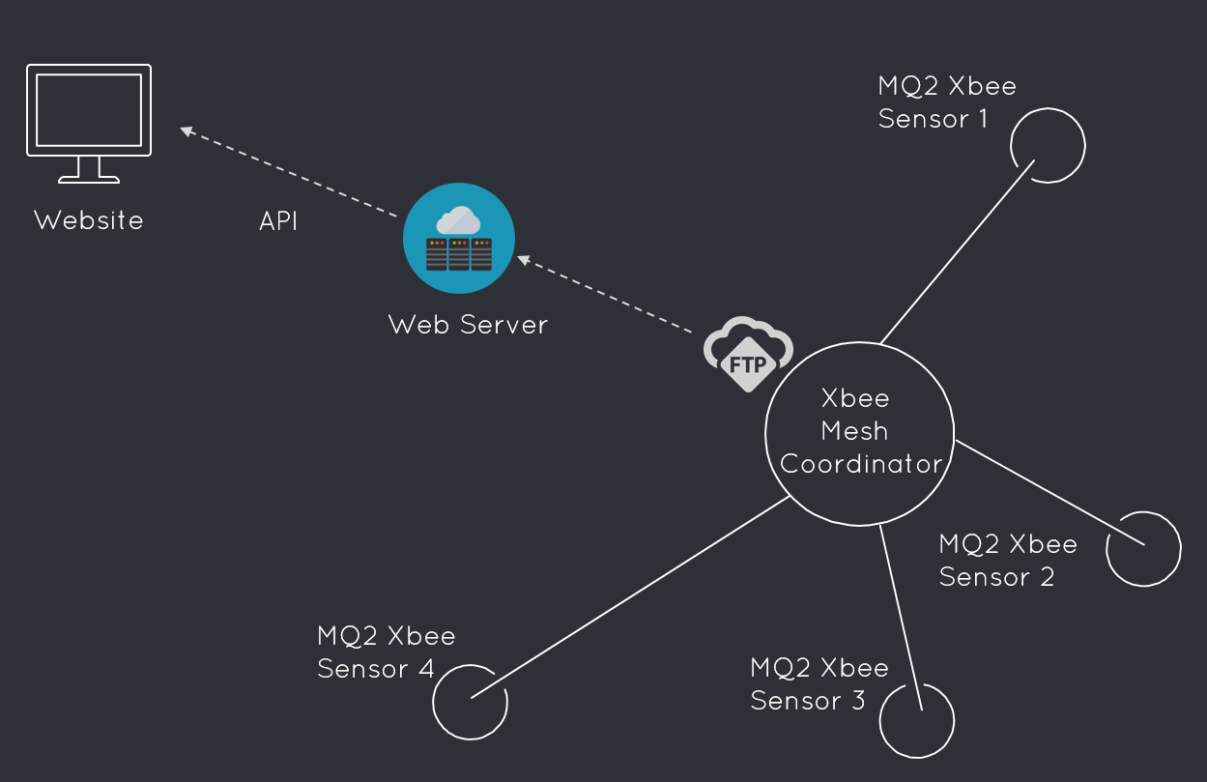

## Procedure/Implementation

Our unique setup consists of 2 main components doing the work of gathering the information and transmitting it to a web presence.

We considered the important factors for monitoring of gases through our platform and included the best sensing techniques with enhanced reliability for providing a robust solution.

To evaluate the performance of gas sensing methods or gas sensors, several indicators were focused:

* Sensitivity: the minimum value of target gases' volume concentration when they could be detected
* Selectivity: the ability of gas sensors to identify a specific gas among a gas mixture
* Response time: the period from the time when gas concentration reaches a specific value to that when sensor generates a warning signal
* Energy consumption
* Reversibility which refers to whether the sensing materials could return to its original state after detection
* Adsorptive capacity which also affects sensitivity and selectivity

Besides, gas sensors designed for the market must guarantee the stability of their operation, in other words, they should exhibit a stable and reproducible signal for a period of time. There are several factors leading to gas sensor's instability (extracted and concluded from):

* Design errors (which should be avoided)
* Structural changes, such as variations of grain size or grain network
* Phase shifts, which usually refers to the segregation of additives doped with sensing materials
* Poisoning triggered by chemical reactions
* Variation of the surrounding environment
* In order to solve these problems, the following methods could be considered:
* Using materials with chemical and thermal stability
* Optimizing elemental composition and grain size of sensing materials
* Utilizing specific technology during surface pretreatment of sensors

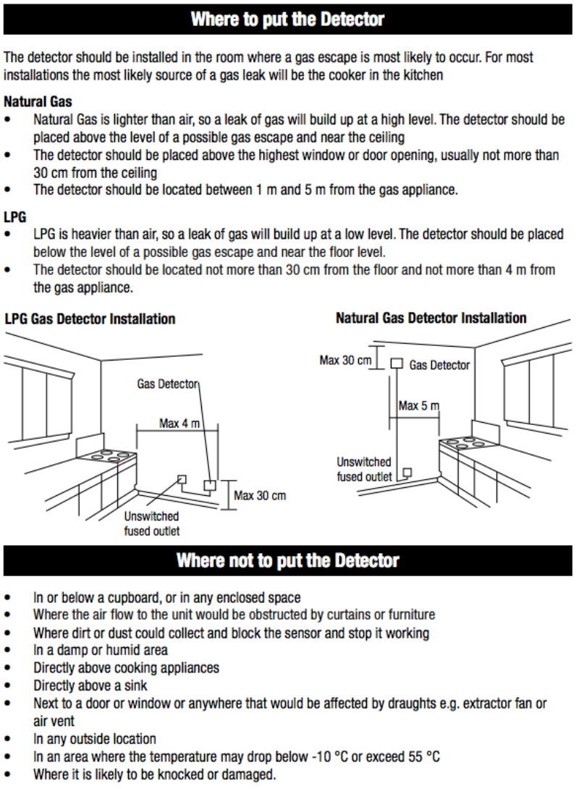Here is a form to know where to place a gas sensor depending on which type of gas you are detecting:

## Cost

**Cost of each end-point:**

Battery: $1

XBee: $17.89

Gas sensors: $3

Box: $10

**TOTAL** = $31.89

**Cost of the central station:**

Ethernet shield: $8.99

Arduino: $25

Box: $3

**TOTAL** = $36.99

**TOTAL** Cost of the kit (one end-point + central station): **$68.88**

**Cost of human resources:**

Five graduate student that worked 60 hours each for $20/hr.: **6,000$**



# Strategy

## Target market segment

Anyone using gas in the home can be at risk from a potential gas leak:

* People who are away from their homes; unless someone is in the property to notice the smell of gas, a leak could potentially build up to dangerous proportions before someone returns home and notices the leak has occurred
* People with a desensitized sense of smell due to age or medical condition
* People with memory issues or people suffering from confusion may forget to light gas rings or may leave gas appliances running, potentially causing a leak to build up.

This makes flammable gas leak detection a concern for any housing professionals, residential care professionals, static caravan holiday park owners or home owners.

## Competition

Recently there have been some sophisticated, inexpensive sensors making the invisible visible, and have the potential to help solve some of our toughest environmental challenges. Sensing technology has been widely investigated and utilized for gas detection. Due to the different applicability and inherent limitations of different gas sensing technologies, researchers have been working on different scenarios with enhanced gas sensor calibration. In this section we will review the descriptions, evaluation, comparison and recent developments in existing gas sensing technologies. A classification of sensing technologies is given, based on the variation of electrical and other properties. Detailed introduction to sensing methods based on electrical variation is discussed through further classification according to sensing materials, including metal oxide semiconductors, polymers, carbon nanotubes, and moisture absorbing materials. Methods based on other kinds of variations such as optical, calorimetric, acoustic and gas-chromatographic, are presented in a general way.

Gas sensing, as a typical application in intelligent systems, is receiving increasing attention in both industry and academia. Gas sensing technology has become more significant because of its widespread and common applications in the following areas:

* Industrial production for example methane detection in mines
* Automotive industry in the detection of polluting gases from vehicles
* Medical applications for example using electronic noses to simulate the human olfactory system
* Indoor air quality supervision (e.g., detection of carbon monoxide)
* Environmental studies in greenhouse gas monitoring

Here is a series of different gas leak detector that we can find on the market. This detectors are not fully automated and even with a single button operation, they still need an human interaction.

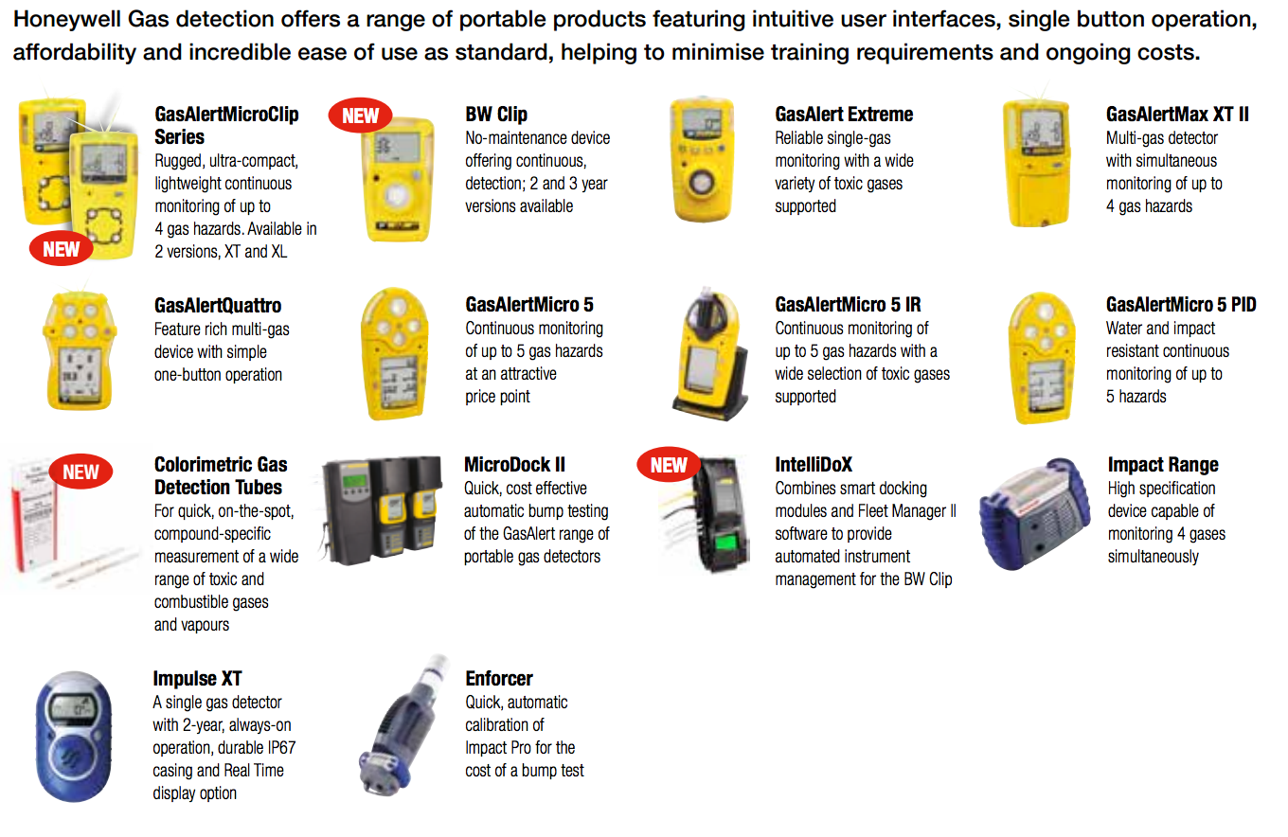

In addition, these sensors are really expensive:

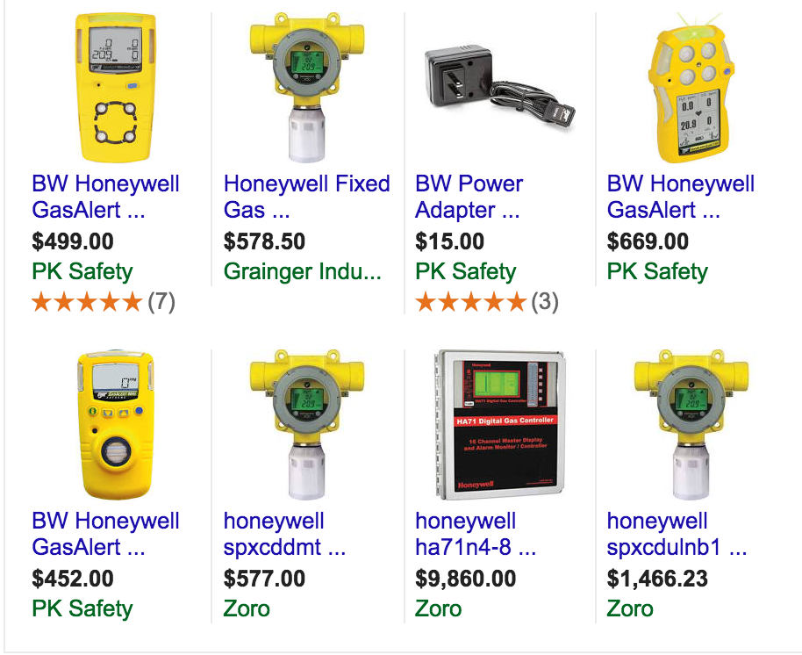

**Closest solution: HF 500**

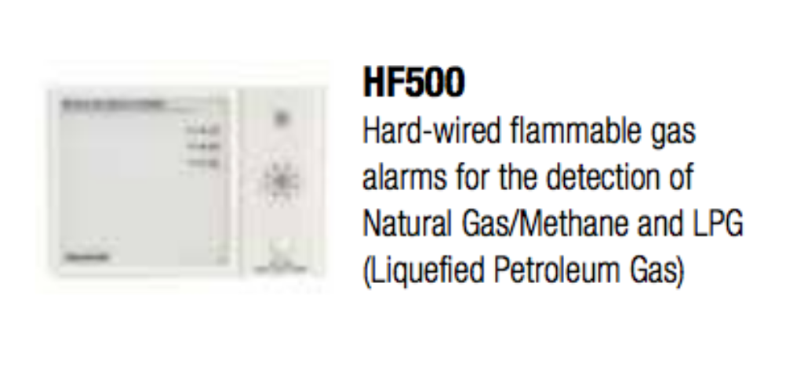This sensor is from the Honeywell Company, it’s an automated gas leak detector that will detect automatically a Natural gas leak or Methane gas leak. But this device will sound an alarm in case of a gas leak in a building. And do not offer any monitoring except from LED placed on the central station you cannot know the current amount of gas in the air or see where actually comes from the leak.

## Unique Value proposition

One of the major unique value proposition of our product is that it’s very user friendly and that it doesn’t required any human action to work. You do not have to operate them manually as it is with other ones where these devices had to be taken regularly to the gas areas to check for any gas leak. Secondly, our product is very cheap compared to other gas sensors. This is because our gas sensors have made use of very affordable components (Arduino) and yet very effective in detecting gas leakage. Besides, our product does not only detect gas leakage but it also transmits the information about gas leakage onto a website. This website can be viewed regularly by the emergency department of any organization so as to know when when and where there is a gas leakage level that could lead to danger of the occupants of that building. Indeed, thanks to our nice map visualization on our website people can exactly determine which sensor has detect a gas leakage.

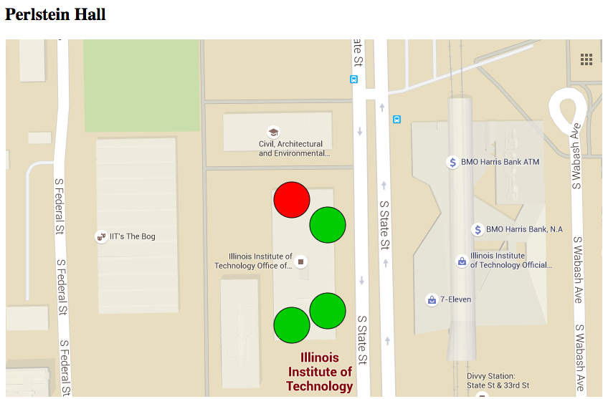

## Lean canvas

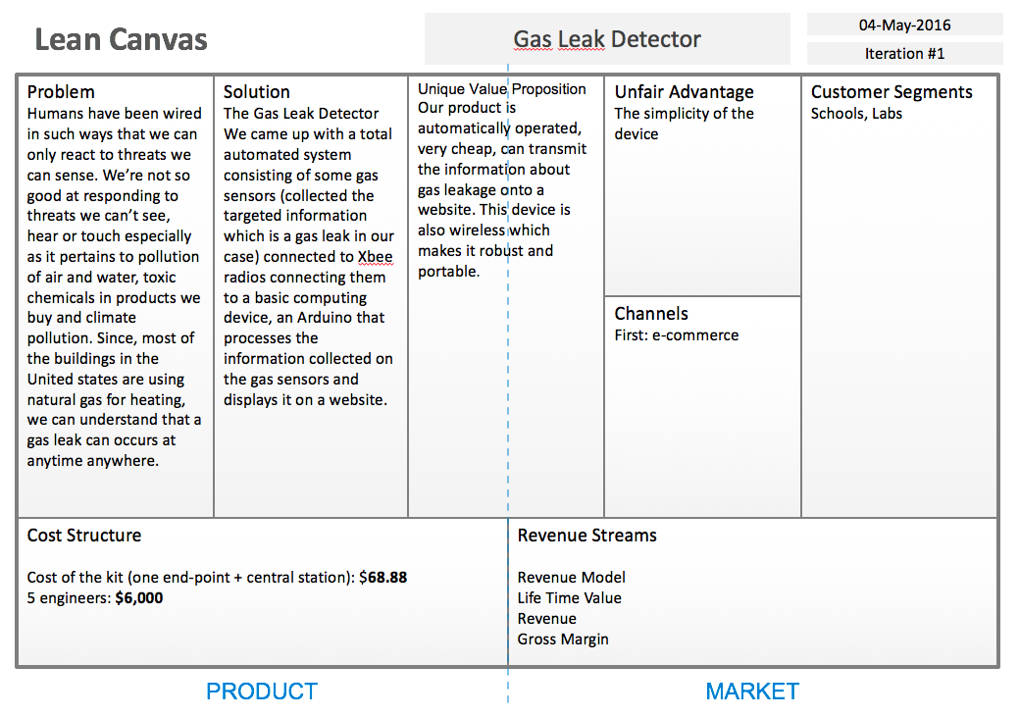

## Future plans

We also think about how we could improve our solution and what would be the next steps if we had more time. And we came up with the idea of an application that will allow student to receive alert notifications on their smartphone in case of a gas leak. We also thought about a valve to provide an automatic gas shut-off system. This feature could be added and integrated to our existing solution.

The next step would probably be to develop our market and brand, so we would have to pay more attention to the marketing part of the project and start thinking about how can we make money with this project. Extend our customers from schools to actual home and laboratories.

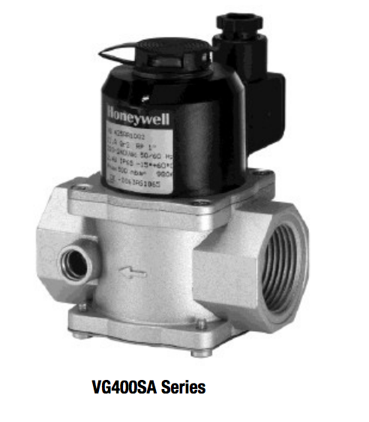

The VG400SA is opened manually and stays open until electrically closed. The body is made out of Aluminum die cast.

# References

* [*http://www.homesafety.honeywell.com/Images/HF500_Datasheet_English.pdf*](http://www.homesafety.honeywell.com/Images/HF500_Datasheet_English.pdf)
* [*http://www.homesafety.honeywell.com/Images/12797_HF500NG_Ops%20Manual_MAN0899_03-13_Iss2_EN.pdf*](http://www.homesafety.honeywell.com/Images/12797_HF500NG_Ops%20Manual_MAN0899_03-13_Iss2_EN.pdf)
* [*http://www.smarthome.com/sensors-security/environmental/smoke-air-sensors.html*](http://www.smarthome.com/sensors-security/environmental/smoke-air-sensors.html)
* *http://www.honeywellanalytics.com/~/media/honeywell-analytics/documents/english/12629_habwfs_prod-range_v11_0315_emea.pdf?la=en-gb*